Project Summary

This project demonstrates a full deployment of Active Directory Domain Services (AD DS) in a virtualized lab environment, including:

* Installing Windows Server
* Configuring static IP addressing
* Promoting server to Domain Controller
* Configuring DNS
* Setting up DHCP
* Creating Organizational Units (OUs)
* User and Group creation
* Group Policies (GPO)
* Login scripts
* Joining Windows clients
* Backup & Restore
* Hyper-V/VirtualBox networking
* AD DS health checks
* AD DS + Azure Hybrid preparation

This documentation is written for recruiters, technical reviewers, and hiring managers.

1. Environment Setup

1.1 Virtualization Platform

VirtualBox (primary virtualization tool)
Enabled:

Virtualization (VT-x/AMD-V)
EFI
TPM 2.0 (when needed)

1.2 Server Configuration
Component | Value
OS | Window Server 2022
Name | DC01
IP Address | 10.59.1.50
Subnet | 255.255.252.0
GateWay | 10.59.1.1
DNS | 10.59.1.50

2. AD DS Installation

2.1 Installing AD DS Role

Using PowerShell:

powershell

Install-WindowsFeature AD-Domain-Services -IncludeManagementTools

2.2 Promoting the Server to a Domain Controller

New Forest
Domain: brightiwara.com
Forest Functional Level: Windows Server 2016+
DNS installed automatically
SYSVOL created

After reboot → Domain Controller is active.

3. DNS Configuration

3.1 Forward Lookup Zones

`brightiwara.com` (Default)
Auto-created A, NS, SOA records

3.2 Reverse Lookup Zone

Created manually for PTR records:

Network: 10.59.1.0/24

3.3 DNS Health Check

Commands used:

powershell
dcdiag /test:dns
nslookup
ipconfig /registerdns

➤ Issue: DNS Unknown
Fix: Set DNS to 10.59.1.50 on the server itself.

4. DHCP Server Configuration

Because the office network already had a DHCP server, mine wasn’t being used at first.

Fix strategy:

Created a separate NAT/Host-Only network for the lab.
DHCP server authorized in AD.

4.1 DHCP Scope Setup

Parameter | Value
Scope Name | 10.159.1.52- 10.59.1.200
Subnet | 255.255.252.0
Gateway | 10.59.1.1
DNS | 10.59.1.50
Lease Time | 8 days

4.2 DHCP Options

Option 3 — Router
Option 6 — DNS
Option 15 — DNS Domain Name

4.3 Reservations

Reserved IPs for:

DC01
File Server (planned)
WDS Server (planned)

5. Organizational Unit (OU) Structure

Created a clean enterprise-ready OU layout:

BrightIwara.com
│
├── _Workstations
├── _Servers
├── _Clients
├── _Finance
├── _GPO
└── _IT Support

6. User & Group Management

6.1 Users

Created test users like:

`testuser1`
`account.finance`

Password policies applied.

6.2 Security Groups

Created:

Finance
IT Support
Domain Admin (additional user)

Group Strategy Used:

AGDLP Model

Accounts → Global → Domain Local → Permissions

7. Group Policy Management

7.1 Important GPOs Created

1. Password Policy
2. Account Lockout Policy
3. Mapped Network Drive
4. Desktop Environment Restrictions
5. Block USB Storage Devices
6. Deploy Wallpaper

7.2 GPO Troubleshooting Commands

powershell
gpupdate /force
gpresult
/rsop.msc

8. Login Script & File Shares

8.1 Network File Share

Created share:

DC01\SharedData`

8.2 Login Script

Example:

cmd
net use M: \\dc01\shareddata /persistent:yes

Applied via GPO.

9. Joining Windows Clients to the Domain

Process:

1. Set DNS to DC01 IP
2. Ping DC01
3. System → Rename → Join Domain
4. Enter domain credentials
5. Restart
6. Verify computer appears in _Clients OU

Clients tested:

Windows 10
Windows 11 (TPM enabled in VirtualBox)

10. Backup & Restore

Backup using Windows Server Backup

Configured:

* Full Server Backup
* System State Backup
* Scheduled weekly backups

Restore Tested

* Restoring SYSVOL
* Restoring AD DS DB

11. VirtualBox Networking Fixes

I solved:

* VM stuck in Scaled Mode
* DHCP conflicts with office network
* Private NAT network creation
* TPM 2.0 configuration for Windows 11
* Expanding VDI disk (Virtual Media Manager → Resize → Diskmgmt.msc → Extend Volume)

12. AD Health Monitoring

Commands used:

powershell
dcdiag /v
repadmin /replsummary
repadmin /showrepl
Get-ADDomain
Get-ADForest

All tests passed successfully.

13. Preparing AD for Azure Hybrid

Steps done:

* Created Azure AD tenant
* Created resource groups
* Downloaded Microsoft Entra Connect
* Installed Entra Connect on DC01
* Enabled Password Hash Sync
* Selected OU Filtering
* Synced users to Azure
* Verified Sync Status using:

* Synchronization Service Manager
* Entra portal → Connect Sync

📌 Screenshot Sections
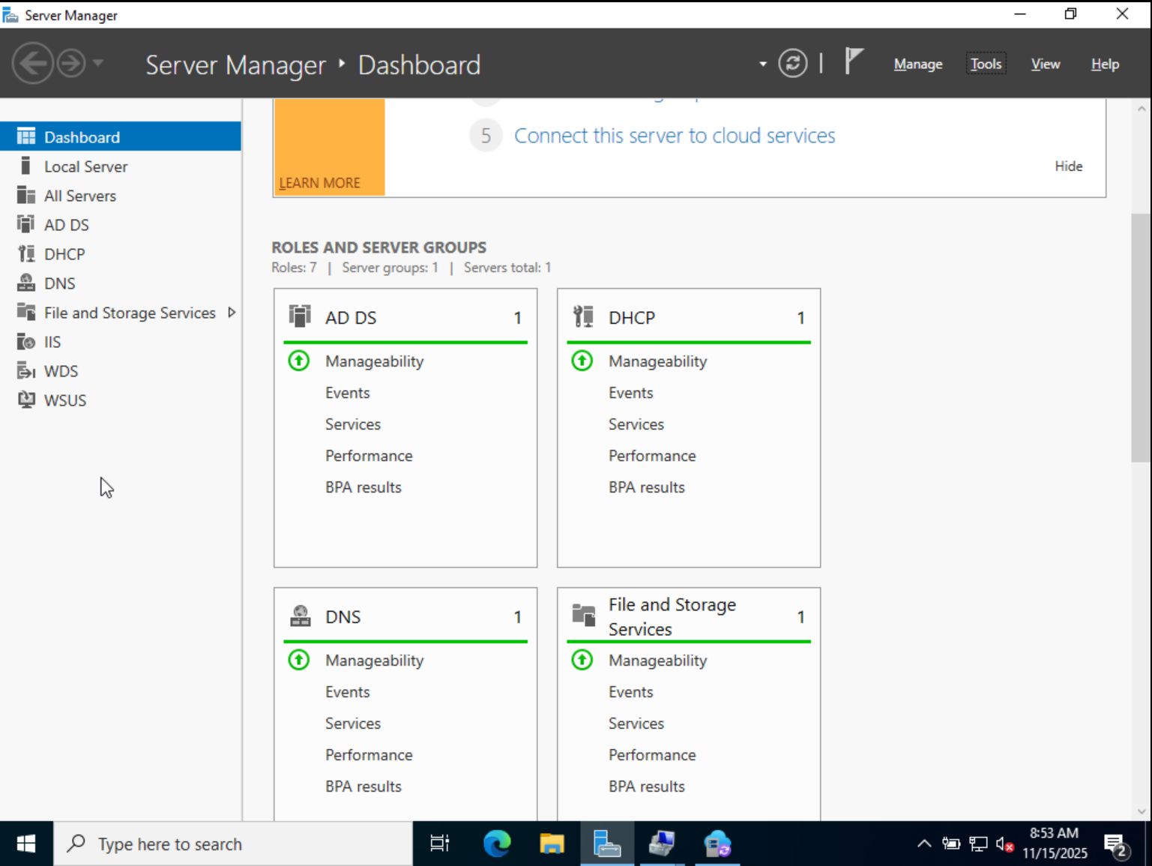

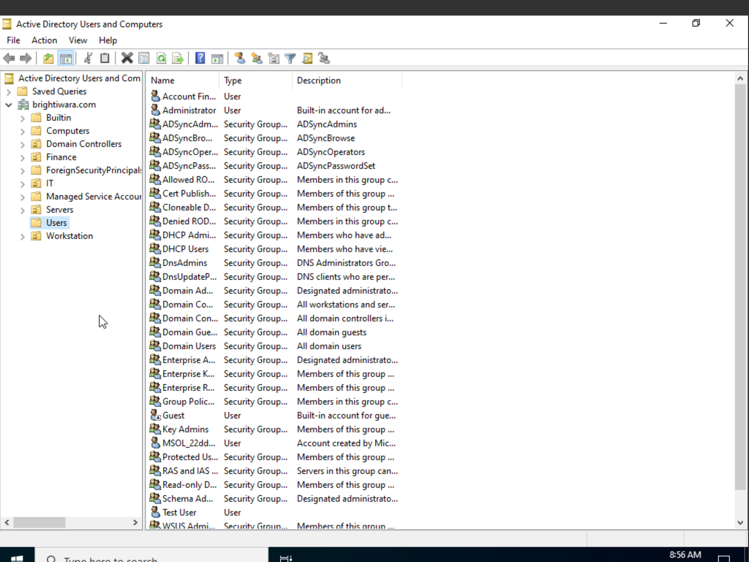

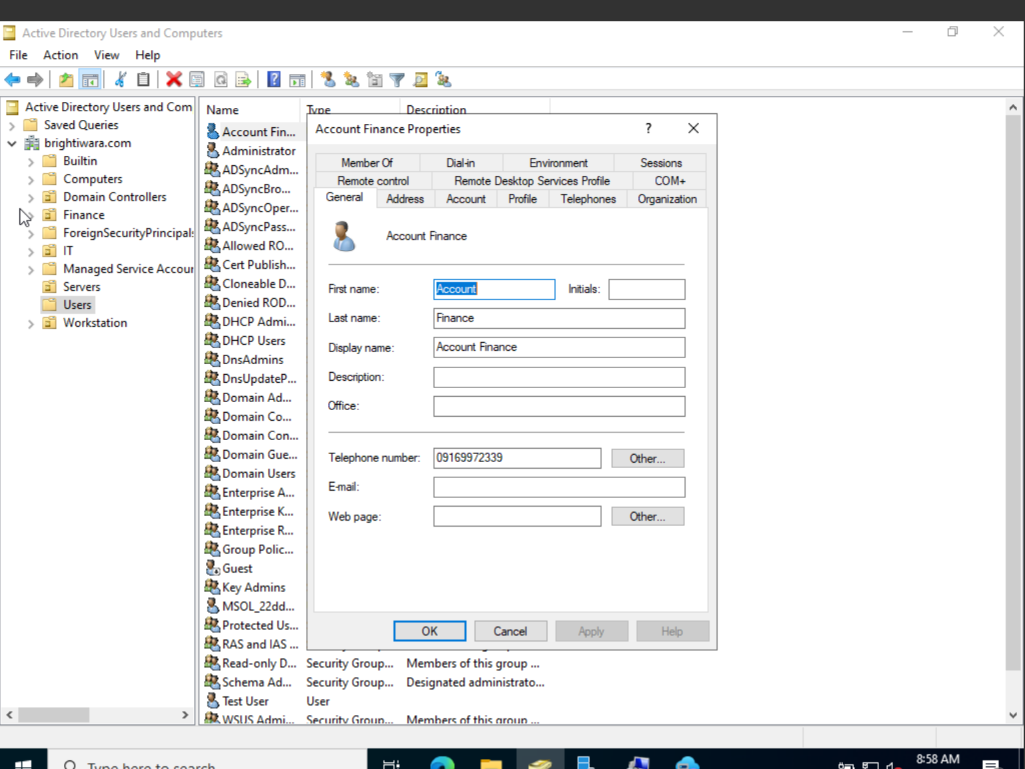

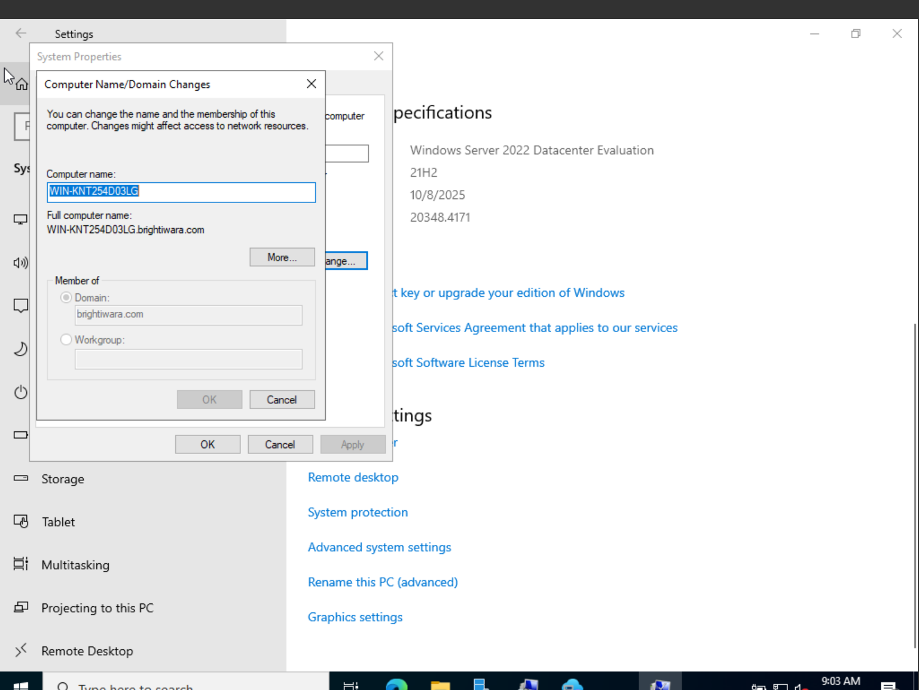

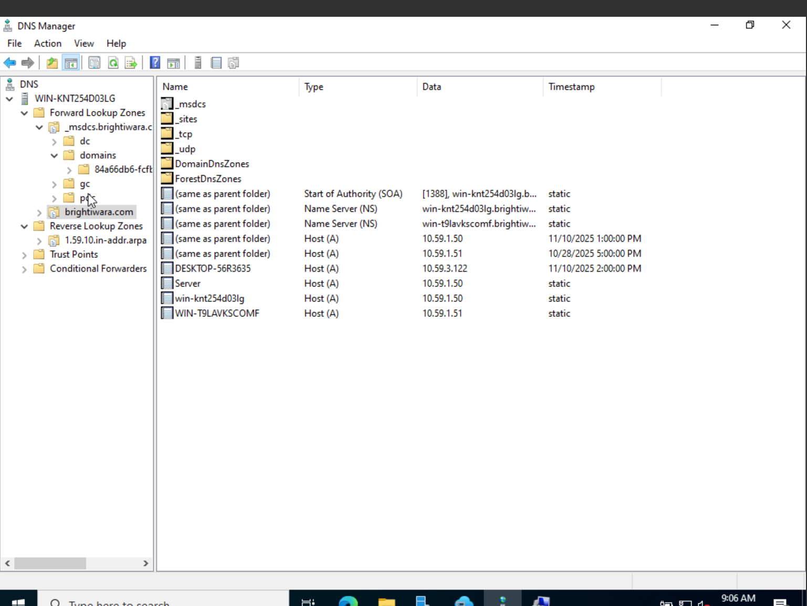

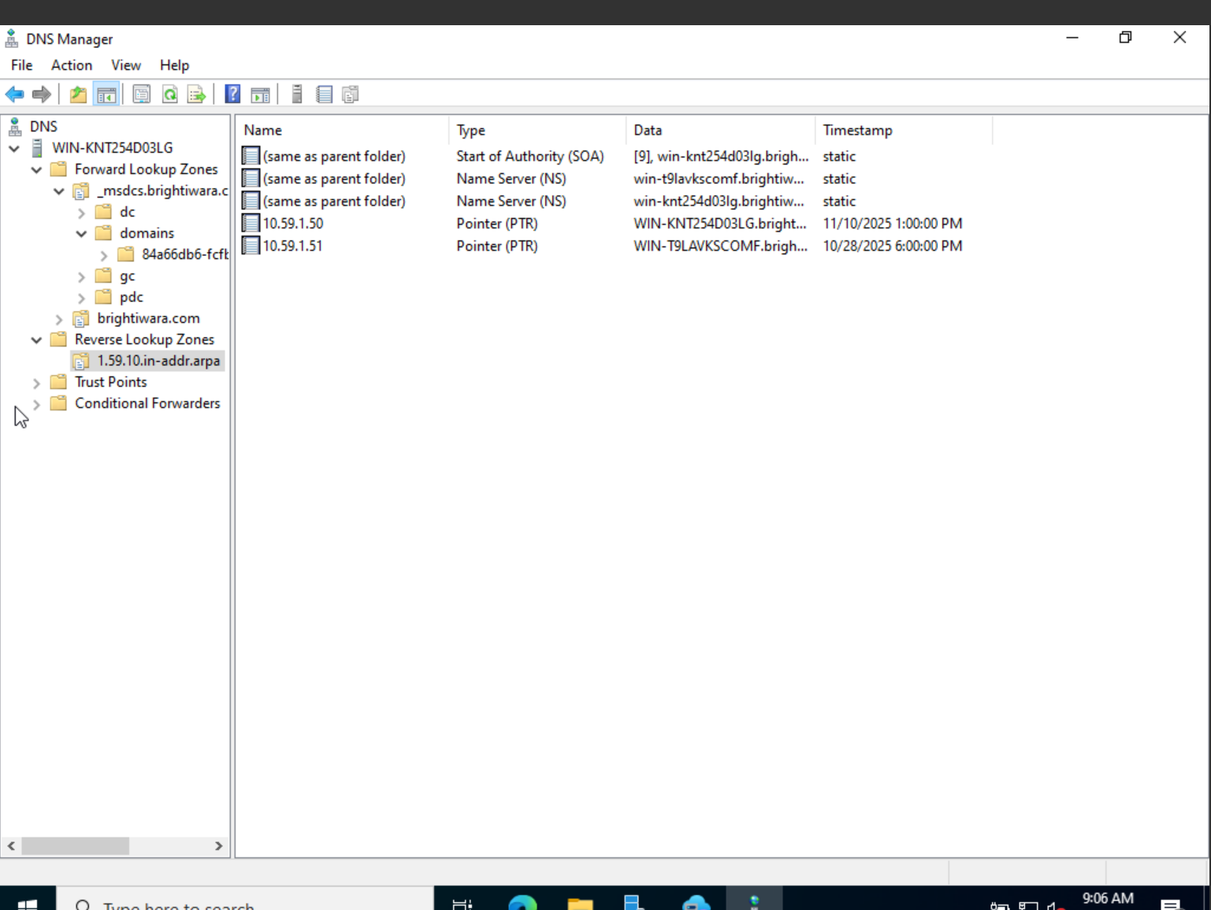

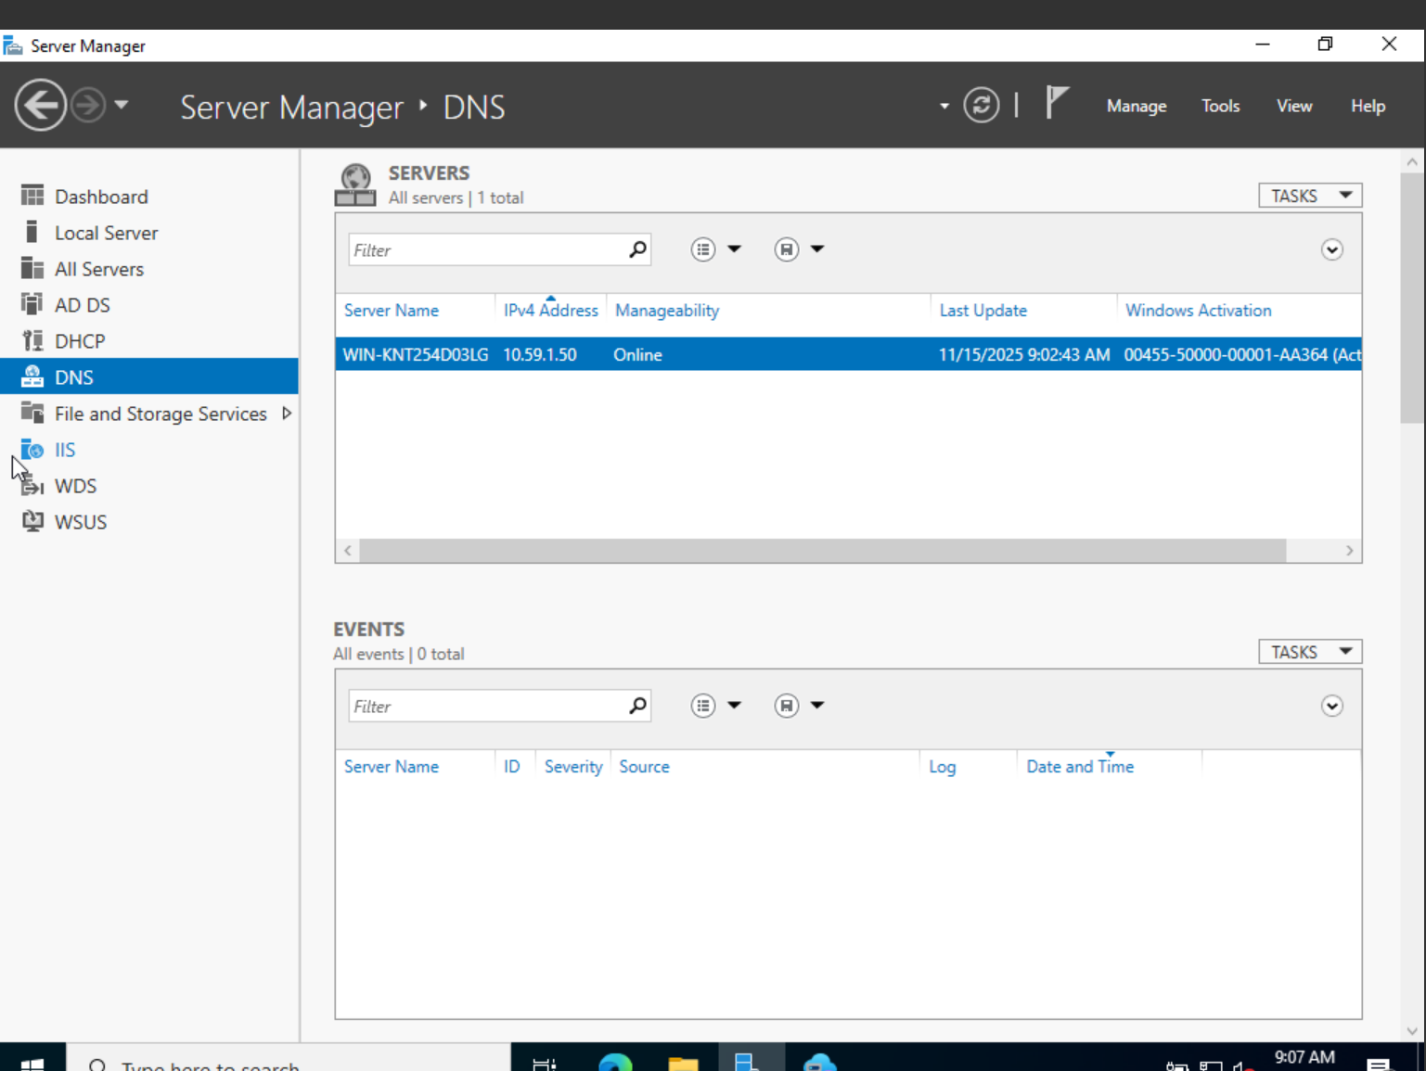

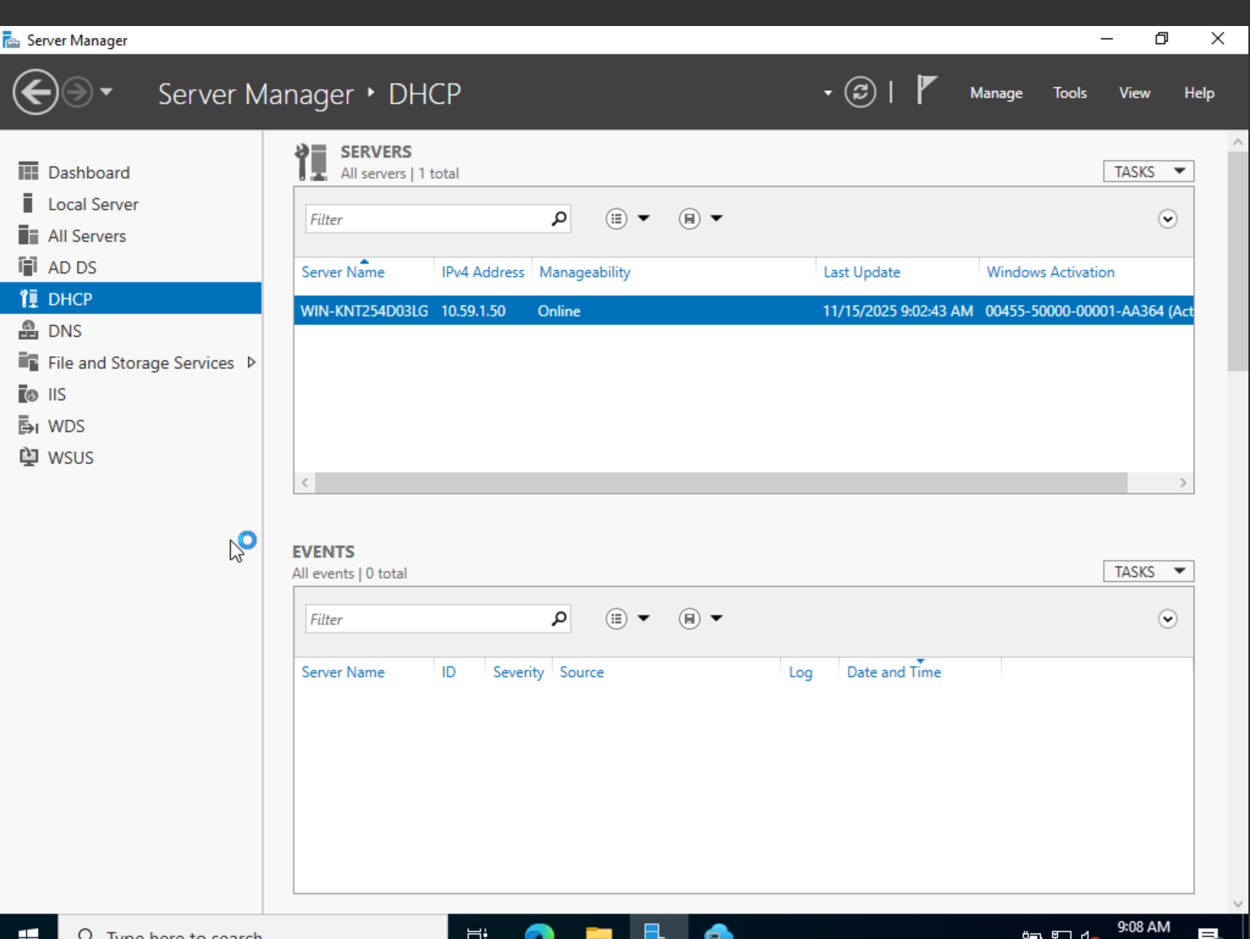

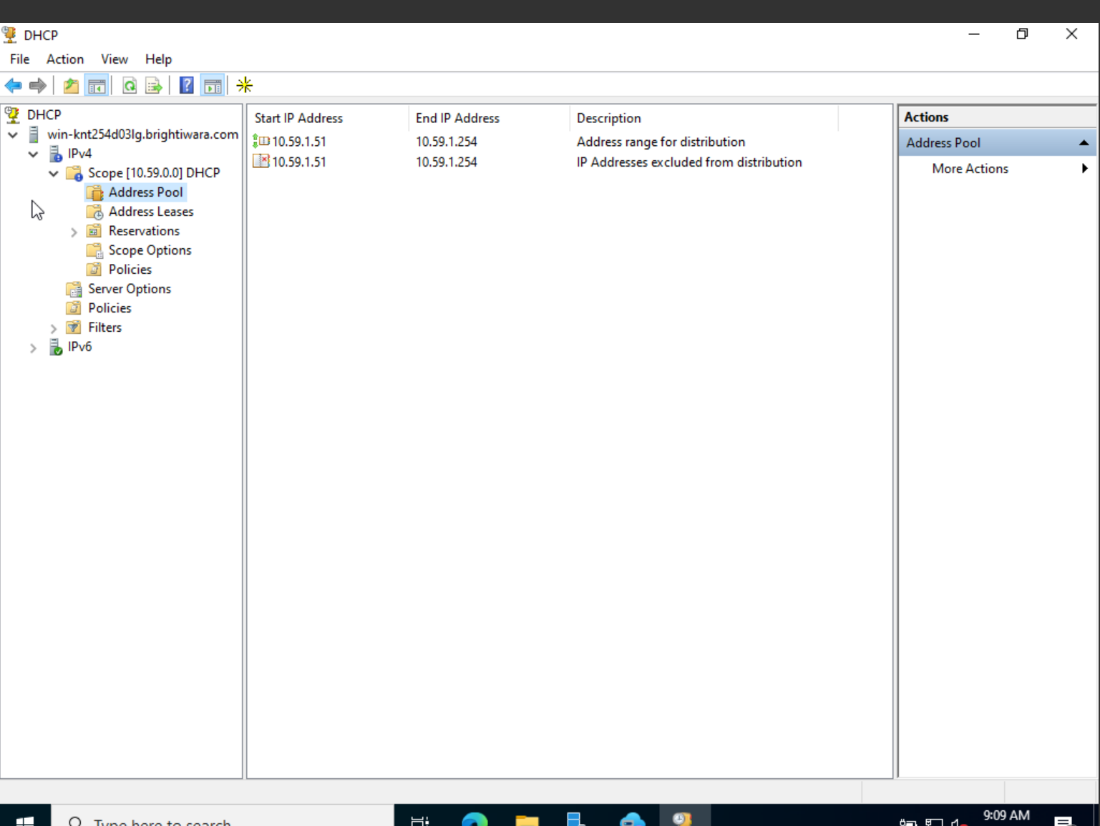

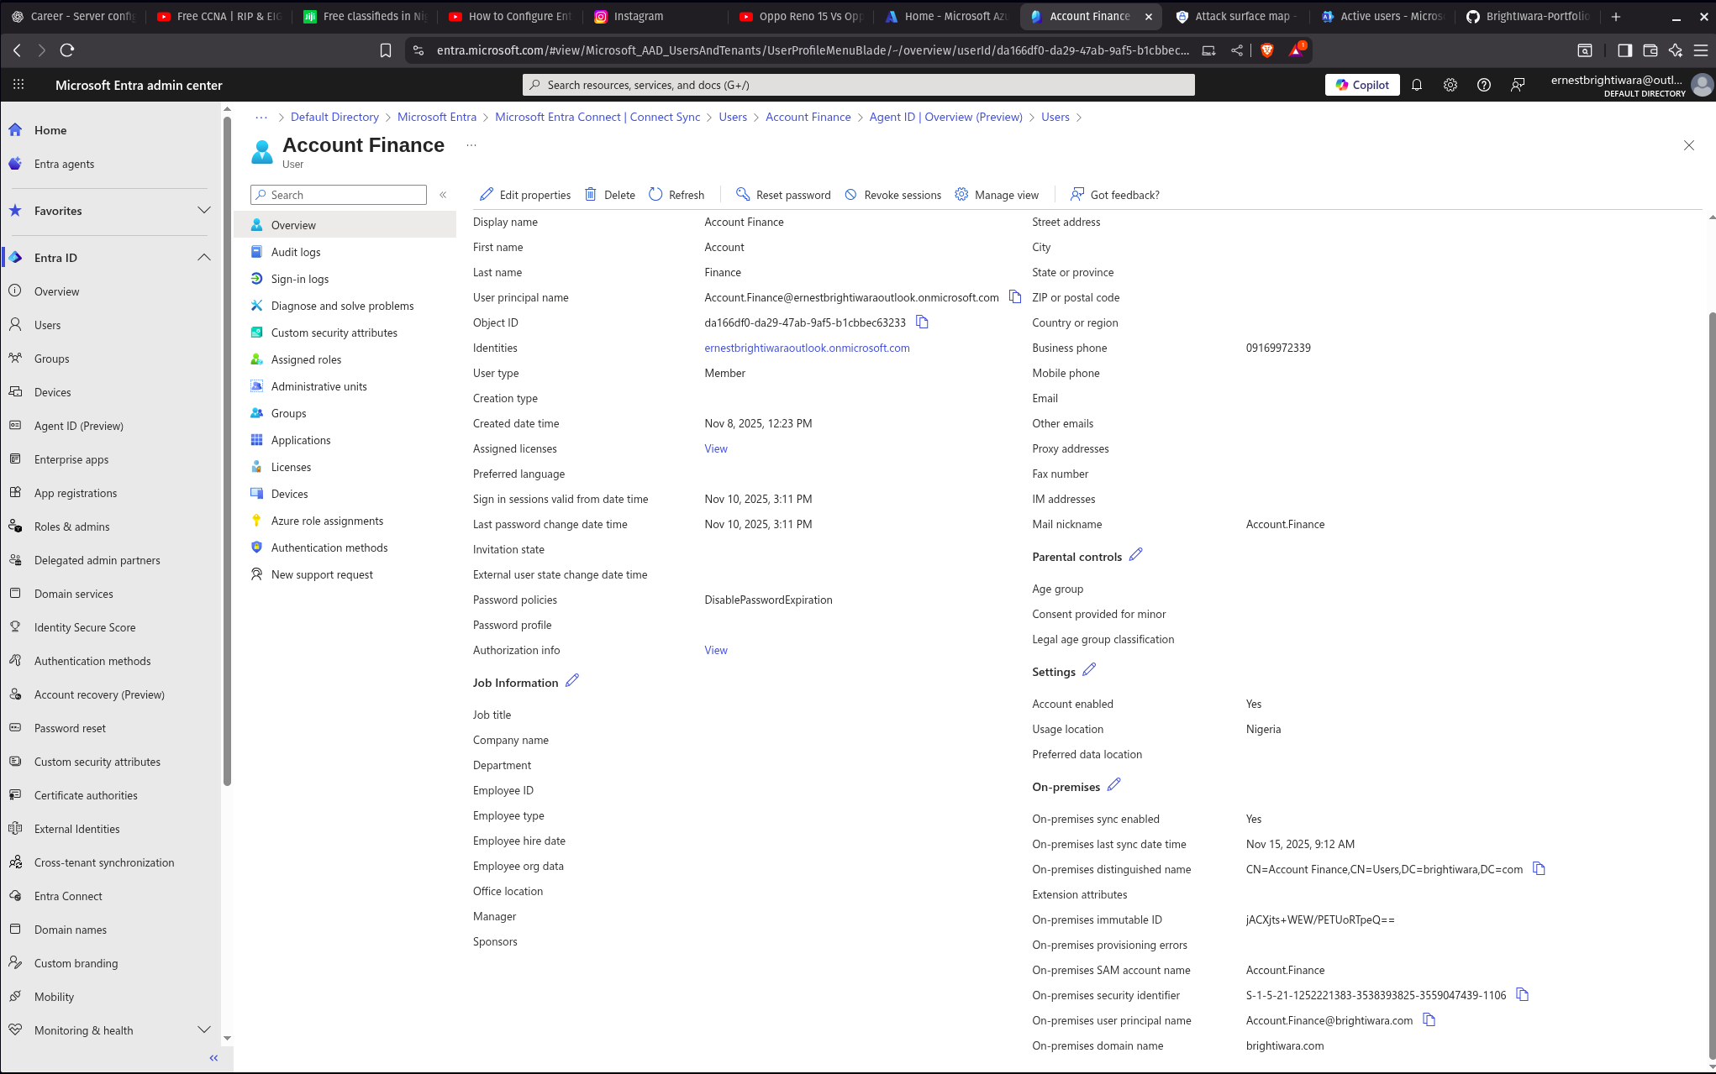

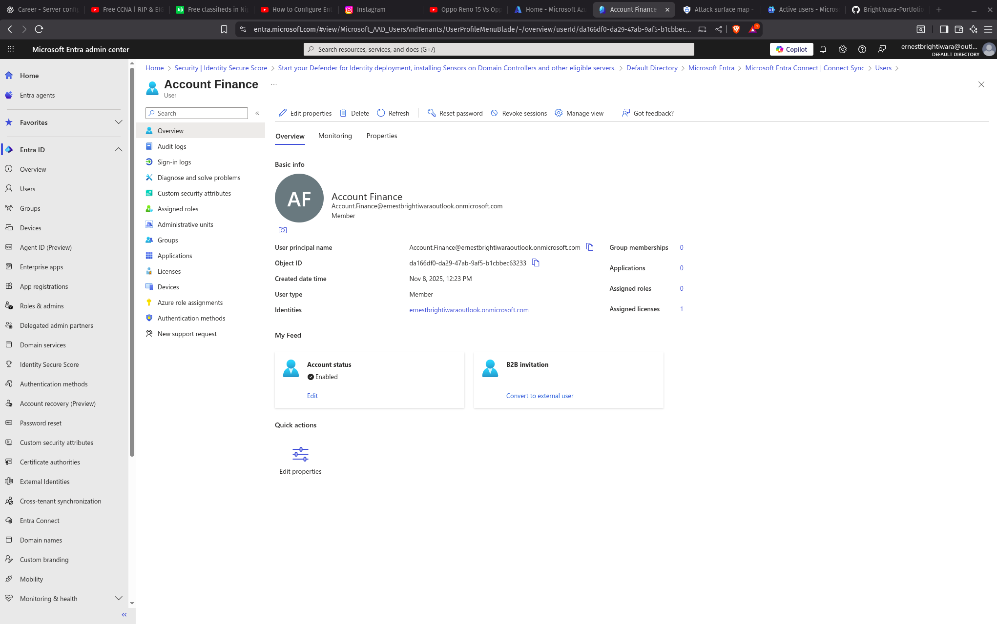

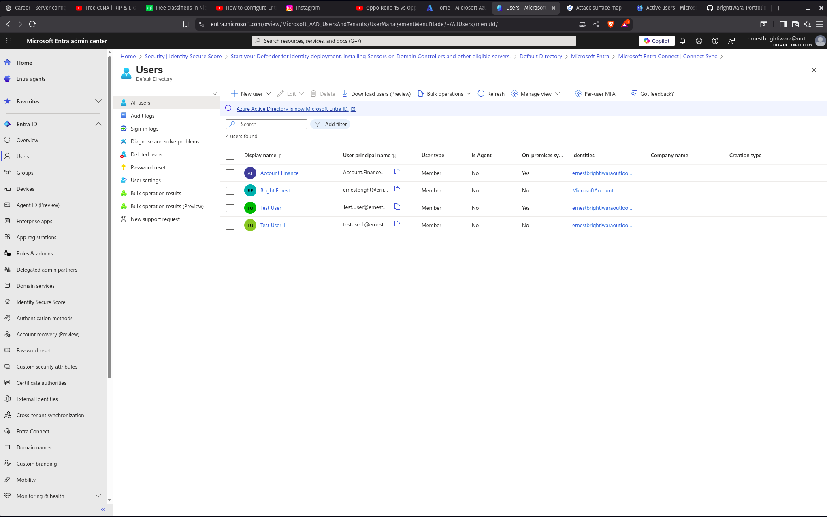

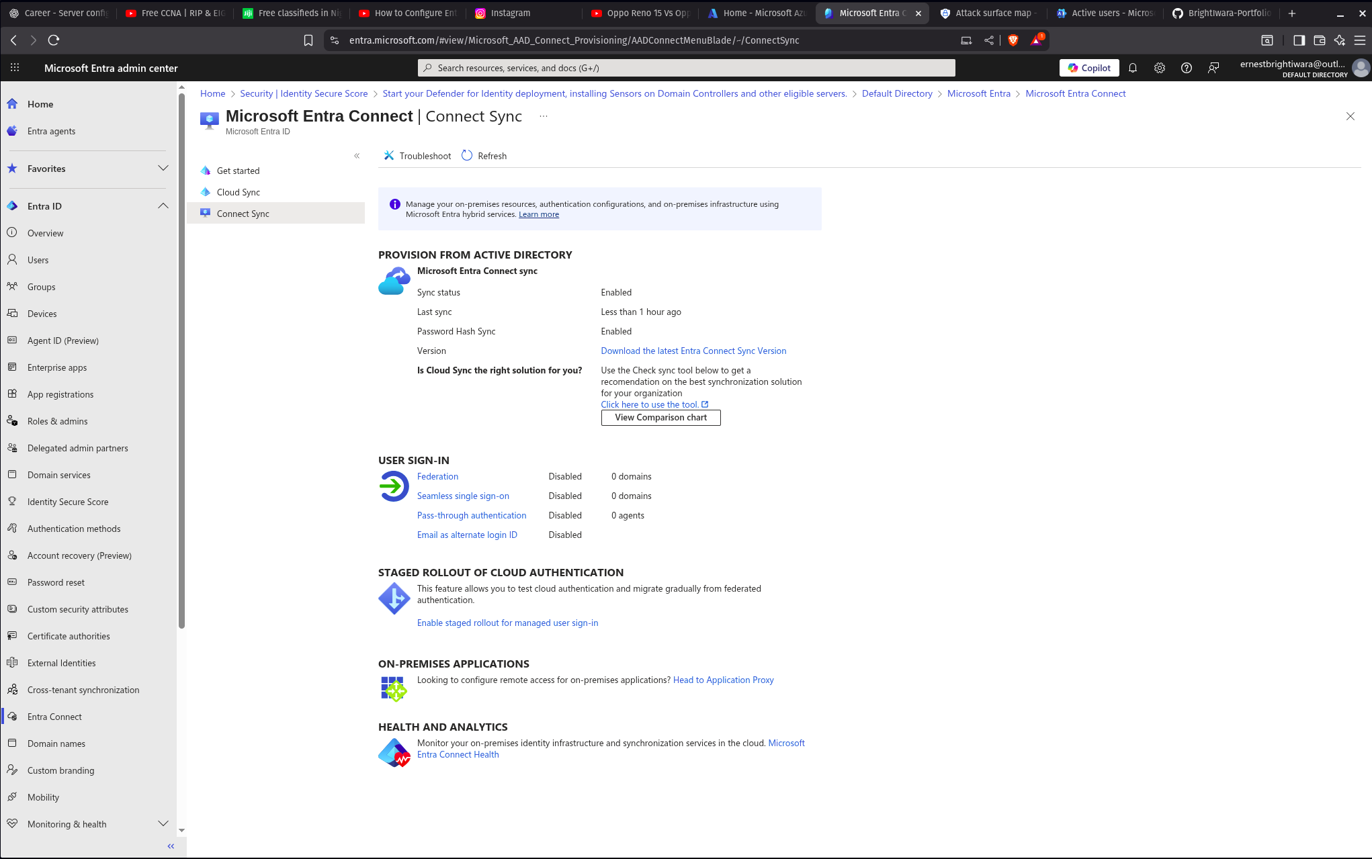

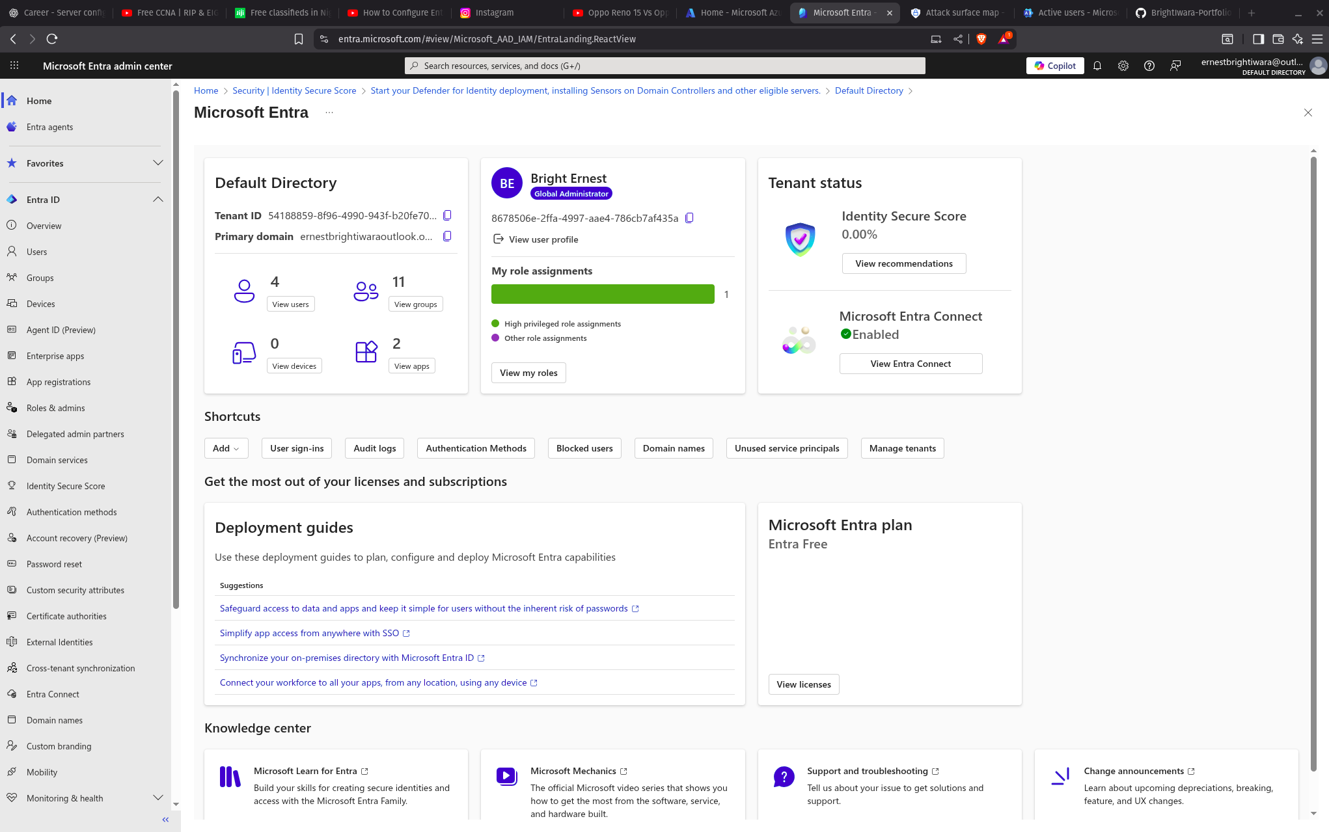

SKILLS:

This project demonstrates my skills in:

* Enterprise Windows Server administration
* Domain Controller deployment
* DNS, DHCP, GPO expertise
* Backup and disaster recovery
* Virtualization
* Hybrid identity (Azure + On-Prem)
* Troubleshooting (networking, AD DS, VirtualBox, Certificates, TPM, Sync, etc.)

